2013 ACE Critique and Awards Program
NMSU Media Productions — Jeanne Gleason

Monster School Bus Game  Class 38:  Interactive Media Program | 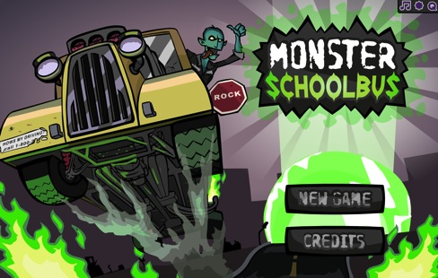
To play the Monster School Bus game, visit mathsnacks.com/monsterschoolbus. To unlock all levels for evaluation, hold down the shift and c buttons on your keyboard to toggle through the unlocked states. (We recommend playing at least the first level completely, or – better yet – watch a mid-schooler play!)
Overview:
Monster School Bus is part of NMSU’s Math Snacks initiative funded by the National Science Foundation. The design team applied the Learning Games Design Model to address the concepts of understanding and representing numbers. This game starts with grouping of numbers in ten-frame mode, and moves into decimals and fractions in later levels. Concepts include:
- Understanding numbers, ways of representing numbers, relationships among numbers, and number systems.
- Visualizing numbers as sets and quantities.
- Building new mathematical knowledge through problem solving.
Of particular interest are the ways in which artistic design influences gameplay. The design of characters and locations gives the game a unique edgy feeling, and provides a more mature feeling to a game covering fairly juvenile content. This is important: though students learn this concept of number chunking in earlier grades, they often fail to understand it conceptually. Therefore, this content could turn off older students if they feel the game is “below them.” The edgy character design helps make the content feel more age-appropriate. Note the ways the buildings “transform” into Monster Buildings as a reward for picking up kids. These beautiful details impact game play and motivate players.
Purpose (goals, objectives, need):
Monster School Bus addresses objectives from the National Common Core mathematics standards, as well as key gaps in mid-school students’ understanding, as reflected through project research. Math Snacks are games, interactive modules and short animations intended to help learners better understand the concepts behind the mathematics content. They are not designed to replace instruction, but to supplement it by making math more accessible. Key concepts are conveyed in a creative, visual, and applied ways.
Team researchers analyzed standardized mathematics test results from over 400 teachers and 24,000 students, identifying the gaps in learning. They then observed classroom instruction and interviewed students and teachers to answer why commonly missed items were misunderstood. Mathematicians, math educators and technology experts worked together to identify classrooms needs, correlate identified gaps with new National Core Standards, and establish Math Snacks Learning Objectives. These objectives led to all Math Snacks games, including Monster School Bus.
Audience:
While this game is designed for middle school content, it has been used successfully with learners in grades 3–8.
Marketing/promotion:
Currently in research phase, almost all Math Snacks are completed or in beta, and use of the tools in randomized control trials has begun. The website is being used by teachers and children engaged in research trials and by those who have been exposed to the product through presentations, articles in journals, during summer teacher training programs, and through online curriculum portals like Edmodo.com. In anticipation of widespread release of the tools in 2014, NMSU is developing a marketing and promotion plan through NMSU’s Math Snacks outreach initiative, supported by a full-time NMSU staff member. The availability of many of these Math Snacks on the Internet, iPhone and iPad makes it possible for students to enjoy Math Snacks games and animations during non-school time as well as in class. The sustainability and commercialization of the products is also being considered, building on current Math Snacks distribution partnerships with BrainPop, the National Council of Teachers of Mathematics (NCTM), and a successfully funded NSF I-Corp proposal to investigate commercialization.
Role of each entrant for the project:
All work, including animation, programming and instructional design, was produced in NMSU’s Media Productions studios. The specific team for Monster School Bus is listed in credits. The overall team includes animators, artists, programmers, designers, content specialists, writers and editors, as well as content experts and researchers from NMSU’s College of Education. All have contributed in the game design process.
Extent to which project met goals and objectives:
Each game is pilot tested throughout development. Beginning in the fall of 2012, the Math Snacks team began initial controlled evaluation using random trials in school and after-school settings. The results of this research have not yet been analyzed, but the anecdotal reports from teachers and the pilot testing trials reveal that Monster School Bus is highly effective at teaching key concepts. Throughout the extensive user testing, the game was played by 20 different groups of kids, yielding suggestions and changes to gameplay and character design. The character design is frequently mentioned as one of the best aspects of the game. In fall, 2012, an external quality assurance committee reviewed the game, commenting extensively on the quality of the graphics.
How diversity was incorporated into entry:
New Mexico has a Hispanic-majority public school student body populations and has long been considered a bellwether for future student body characteristics in the United States. Without competency in mathematics, students – particularly those in low-income areas, English language learners and students with special needs – are limited in their course and career options in STEM fields. Math Snacks has a proven track record of creating innovative products for all learners, with a design approach that involves underrepresented students throughout the design, development and testing phases of the products. Products have been tested extensively with diverse students and been reviewed by independent quality assurance panels annually, with specific attention paid to accessibility by diverse audiences and cultural sensitivity. Funders, such as the National Science Foundation, have found that interactive modules that test well with New Mexican students are often highly effective in increasing readiness to grasp STEM-related concepts within a national student population.

